SDM COLLEGE OF ENGINEERING AND TECHNOLOGY,
Dharwad-580002
An autonomous Institution affiliated to
Visvesvaraya Technological University, Belgaum – 590018



Department of Electronics and Communication Engineering

A Synopsis on Minor Project-2 entitled

“Enhanced Road Accident Alerting System using ESP32 and LI-FI Technology”

Submitted by :
GURUPRASAD YADAV - 2SD22EC023
MANOJ HALAPETI - 2SD22EC037
MEENAPPA TARANALLI - 2SD22EC038
OM V HIREMATH - 2SD22EC047
Students of 6th Semester,
Bachelor of Engineering in Electronics and Communication.

Under the Guidance of

Prof. SUMANGALA BHAVIKATTI.
Designation : Assistant Professor, Dept. of ECE

Academic year : 2025-26

1. Introduction:

The "Enhanced Road Accident Alerting System using ESP32 and Li-Fi Technology" aims to revolutionize how road accidents are detected and communicated, enhancing road safety by providing real-time accident alerts to emergency services and nearby vehicles. Traditional systems often rely on cellular networks or GPS, which can be unreliable in certain areas or situations, such as when there is poor signal coverage. This system proposes a more efficient and immediate solution by integrating ESP32 (a low-cost, low-power microcontroller) and Li-Fi technology (Light Fidelity), which uses visible light for high-speed communication.

2. Problem Statement:

Road accidents, especially in remote or poorly connected areas, often go unnoticed for critical periods, delaying emergency response times and increasing fatalities. Current systems relying on cellular networks and GPS sometimes fail to deliver real-time updates due to poor connectivity. This delay can hinder timely medical help and rescue operations. A more robust, efficient, and reliable communication system is necessary for improving road safety.

3. Objectives:

- Real-time Accident Detection: Detect road accidents immediately after they occur and trigger automatic alerts.
- Wireless Communication: Utilize Li-Fi technology for faster and secure communication, as it can overcome the limitations of traditional wireless systems like Wi-Fi and Bluetooth.
- Emergency Alerting: Alert nearby vehicles and emergency services (e.g., police, ambulances) in real-time with crucial accident details, such as location and severity.
- Low Power Consumption: Leverage ESP32's energy-efficient architecture to ensure continuous operation with minimal power usage, particularly in remote locations.

4. Block Diagram:

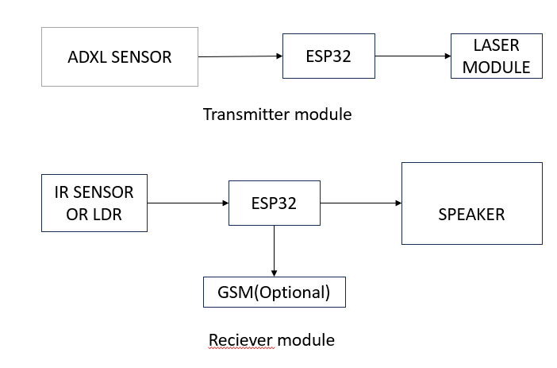
Fig: Block diagram for connections.

5. Components and Technologies:

- ESP32 Microcontroller:

  - A highly capable microcontroller that features Wi-Fi and Bluetooth capabilities.
  - Acts as the central unit of the system, managing sensor data, processing signals, and sending alerts.
  - Handles the communication and controls the entire system, making it ideal for IoT applications.

- Li-Fi (Light Fidelity) Technology:
  - A wireless communication technology that uses light waves (typically from LEDs) instead of radio waves.
  - Provides a fast and secure alternative to traditional wireless communication, such as Wi-Fi.

  - Transmits data by modulating light, which is more efficient and less prone to interference.
  - Li-Fi can provide communication over short to medium-range distances (ideal for vehicle-to-vehicle or vehicle-to-infrastructure communication).

- Sensors:
  - Accident Detection Sensors: Sensors such as accelerometers or gyroscopes integrated with the vehicle will detect abnormal vehicle movements that indicate an accident (e.g., a sudden crash or impact).
  - Location Tracking (GPS): Used to identify the exact location of the accident in real-time, which is essential for quick dispatch of emergency services.

6. System Architecture:
- Accident Detection:
  - The vehicle is equipped with accelerometers or gyroscopic sensors that continuously monitor the motion of the vehicle.
  - In the event of an accident, the sensor detects an abnormality (e.g., a sudden stop or collision) and triggers the system.
- Data Processing (ESP32):
  - Once the accident is detected, the ESP32 microcontroller processes the sensor data, including impact intensity, time, and location (from GPS).
  - The microcontroller also identifies whether the accident is severe enough to warrant an alert, based on predefined thresholds.
- Communication via Li-Fi:
  - The system uses Li-Fi technology to communicate accident data to nearby vehicles, infrastructure, or emergency services.
  - Li-Fi is implemented using light sources such as LED lights or street lamps, which can carry accident alerts at high speed over short distances.
  - The Li-Fi signal is received by nearby vehicles or road sensors that are also equipped with Li-Fi receivers, allowing for real-time alerts on vehicles' infotainment systems or dashboard displays.

- Alerting Emergency Services:
  - In addition to alerting other vehicles, the ESP32 system can send the accident data to a cloud server via Wi-Fi, which then sends notifications to emergency services (police, ambulance).
  - The alert includes crucial information such as the accident location, severity, and possible casualties.
- Feedback and Updates:
  - Emergency services can send updates or feedback to nearby vehicles or road users through the Li-Fi network, keeping all parties informed about the ongoing situation and ensuring safe routing.

7.Advantages of the System:

- Enhanced Real-Time Communication: Li-Fi provides faster, secure, and interference-resistant communication compared to traditional wireless methods, ensuring rapid transmission of accident alerts.
- Reduced Dependence on Cellular Networks: The system doesn’t rely on cellular coverage, which is a significant advantage in remote or rural areas where signal strength may be weak.
- Low Latency: Li-Fi offers low latency communication, meaning emergency alerts can be transmitted almost instantaneously.
- Improved Road Safety: By providing real-time accident alerts to surrounding vehicles and emergency services, the system can reduce secondary accidents and improve response times, potentially saving lives.
- Energy Efficiency: ESP32 is designed to consume minimal power, which is crucial for ensuring that the system operates efficiently over long periods without requiring frequent recharging.

8.Challenges and Limitations:

- Limited Range of Li-Fi: Li-Fi has a limited range (line-of-sight communication), meaning it may not be effective in scenarios where the signal path is obstructed (e.g., by tall buildings or trees).

- Infrastructure Deployment: Implementing Li-Fi requires the installation of Li-Fi-enabled infrastructure (e.g., street lights, vehicles), which could involve a significant upfront cost and coordination with local authorities.
- Cost of Sensors: Although the ESP32 is cost-effective, integrating high-quality accident detection sensors, GPS modules, and Li-Fi technology might increase the overall cost of deployment.
- Interference from Environmental Conditions: Li-Fi may be affected by environmental factors such as fog, rain, or glare, which could disrupt communication.

9. Conclusion:

The Enhanced Road Accident Alerting System using ESP32 and Li-Fi technology offers a promising solution to improve road safety. By integrating these advanced technologies, the system can deliver faster, more reliable accident alerts, ultimately saving lives and reducing the impact of road accidents. While challenges remain in terms of infrastructure and environmental factors, the potential benefits of such a system are significant in enhancing real-time communication and response efforts in road safety management.
This system has the potential to reshape the future of intelligent transport systems (ITS), improving both accident detection and the response capabilities of emergency services.

